1. BRAINSTORMING & IDEATION PHASE
EduGenie: Google Gemini Powered Learning Assistant
This phase identifies the educational problem, target users, and the main idea behind EduGenie. The project document describes EduGenie as a lightweight AI-powered educational assistant designed for students of all academic levels.
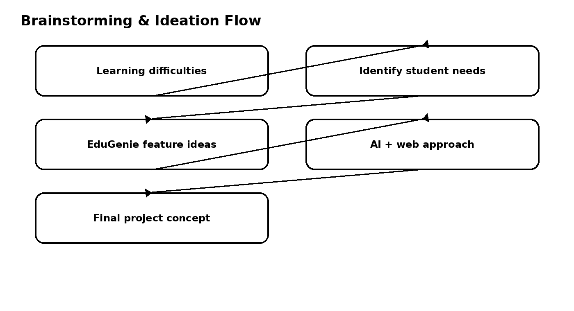

1.1 Problem Identification
- Students may need quick answers to academic questions.
- Complex concepts may need to be explained in simple language.
- Long educational passages may be difficult to revise quickly.
- Learners may need quizzes to check understanding.
- Students may benefit from structured learning recommendations.

1.2 Proposed Idea: EduGenie
- Ask questions and receive smart, concise answers.
- Understand complex concepts through simplified explanations.
- Generate quizzes from topics or text.
- Receive personalized learning recommendations.
- Summarize large educational passages.

1.3 Example User Scenarios
- A student asks: “Which is the largest ocean?”
- A student uses “Generate Quiz” to check understanding of the Pythagoras Theorem.
- A learner exploring SQL requests a beginner-to-advanced learning path with timelines and resources.

1.4 Ideation Outcome
The ideation phase results in a web-based AI learning assistant combining a simple HTML+CSS interface, FastAPI backend, Google Gemini cloud intelligence, and a lightweight local model for concept explanation.

